Vehicle Registration Form

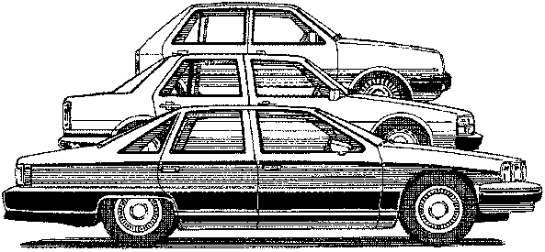

Please complete all of the information in the spaces provided.

Name: ___________________________________________________________________

Unit Address: _________________________

Applicant Is: __ Owner ___ Renter (CHECK ONE)

Phone: (h) ___(w) ___(c) _____________

Email:____________________________________________________________________

Vehicle Information

YEAR / MAKE / MODEL | COLOR | LICENSE PLATE # | STATE

________________________________ ______________________________
Signature Date

