EXTERIOR ALTERATION APPLICATION

WARNING: Exterior alterations commenced without prior approval of the Covenants Committee and/or the Board of Directors is in violation of the covenants and is at the homeowners' own risk. All cost associated with returning the area to its original condition, should the request be disapproved, shall be the unit owners expense

Name:_____________________________________________________________________________

Address: __________________________________________________Virginia Beach, Virginia 23454

Phone: Home: ____________________ Work:_____________________Cell:____________________

APPLICATION FOR: (check appropriate work-you may check more than one)

New Construction_____ Awnings _____ Relocate _____ Other_____
Repair_____ Existing Structure_____ Yard Ornaments_____
Alteration_____ Building_____ Porch Rails_____
Landscaping_____ Fence_____ Grading_____
Excavation_____ Porch_____ Deck_____

Project is expected to begin on ________________________ and be completed by __________________________

DESCRIPTION OF ALTERATION: Supplemental sheets, sketches, plats and drawings that fully describe the proposed alteration must be attached before the ACC will review the application. In case of an exterior color change, a sample of the new color along with a description of the existing color must be submitted.

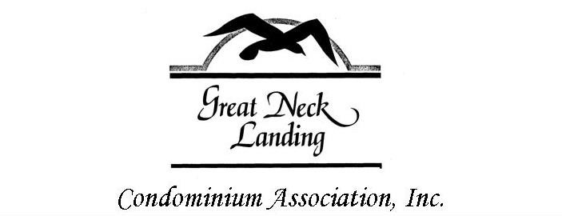
ACKNOWLEDGEMENT: Please obtain four signatures of adjacent and/or visually affected neighbors for an alteration visibly noticeable from the common elements or another neighbor’s backyard. Acknowledgement indicates awareness of intent, not necessarily approval or disapproval.

NAME:_______________________________ NAME:_________________________________

ADDRESS:____________________________ ADDRESS:______________________________

NAME:_______________________________ NAME:_________________________________

ADDRESS:____________________________ ADDRESS:______________________________

NOTE: The Board of Directors has forty-five (45) days from the date an application has been received to approve or disapprove each application.

OWNER'S SIGNATURE____________________________________ DATE_____________________

Please mail or deliver to: GREAT NECK LANDING CONDOMINIUM ASSOCIATION c/o The Select Group, Inc.
2224 Virginia Beach Blvd., Suites 201/202
Virginia Beach, VA 23454
Or Fax to (757) 486-6988
Should you prefer to e-mail your application, e-mail addresses for the Great Neck Landing management team can be found on our website.
c/o The Select Group, Inc. 2224 Virginia Beach Blvd. Suite 201/202 Virginia Beach, VA 23454 (757) 486-6000 Fax: (757) 486-6988 Email: select@theselectgroup.us Website: www.theselectgroup.us

